



As a current BFA and Design Teacher Education student at the University of Limerick and Limerick School of Art and Design, I possess a diverse skill set honed through experiences in marketing, customer service, and stock taking. With a passion for both my studies and practical application, I am eager to transition into a professional career. While my formal teaching experience currently spans a 3.5-month placement with first, second, transition year, and fifth-year students, I am determined to be an asset to any team or educational setting. With a proactive approach and a commitment to creating positive experiences, I am confident in my ability to make a valuable contribution. I welcome the opportunity to discuss how my skills and enthusiasm align with your needs.

PROFESSIONAL SUMMARY
Hannahcoffey64@gmail.com

Teaching Practice, Art Student Teacher
Borrisokane Community College, Tipperary, 2023 – 2024

- During my student teacher placement, I had the invaluable opportunity to teach art and design to first, second, third, and fifth-year students. Throughout this experience, I engaged in a dynamic process of lesson planning, classroom management, and student assessment. By catering to the needs of diverse age groups and skill levels, I honed my adaptability and communication skills. Additionally, collaborating with experienced educators allowed me to learn effective teaching strategies and pedagogical approaches . I had two successful inspections and continued into final year. This placement enriched my teaching repertoire by demonstrating my versatility, dedication, and ability to thrive in a professional educational setting.

Marketing, Head Waitress & Delicatessen Manager
The Pantry Café Nenagh, Tipperary, 2018 – 2025

A customer facing roll. I have been working part time here since I was 14 and it has given me great interpersonal skills to succeed. I have dipped my toe in nearly every aspect of the business from waitressing, staffing, cash management, barista training courses and event catering. With my love of social media, I took ownership of the marketing running the social media accounts.

- Social Media Manager: social media management and digital management, promoting products, services. Engaging with the community online and growing our followers, interacting and consulting with customers enquiries and orders. Content creation and ideation using my camera and editing tools such as Adobe Illustrator, Photoshop, Premier Pro and Canva. I then used a content scheduler called Buffer to schedule content for the month.
- Hospitality: professional waitress and caterer with five years of experience in food and beverage. Related services including shift management, stock control, training. Overseeing training and professional growth of new staff on service expectations, health/safety procedures, and protocols, ensuring high level of customer service. Managed opening and closing duties including handling the cash drawer.

Rome Art Programme, June 2025
- Selected by the Board of Directors to participate in the prestigious Rome Art Programme.
- Awarded a $500 work-study scholarship in recognition of artistic merit.
- Immersive month-long program in Rome focused on art history, architecture, and plein air painting.
- Engaged in intensive study and creative exploration within the historical and cultural heart of Italy.
- Opportunity to develop artistic practice while gaining a deeper understanding of classical and contemporary influences in art.

Nenagh, Tipperary
083 451 2126
Leaving Cert
Borrisokane Community College Secondary School
2015 – 2021

Fourth Year Student Level 8 Joint University degree in ‘Fine Art & Design Teacher Education’ Technological University of Shannon and University Limerick
2021 – Ongoing

EDUCATION
PROFESSIONAL EXPERIENCE
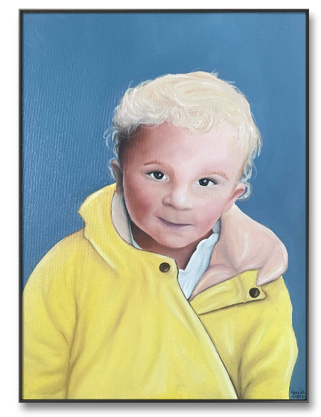
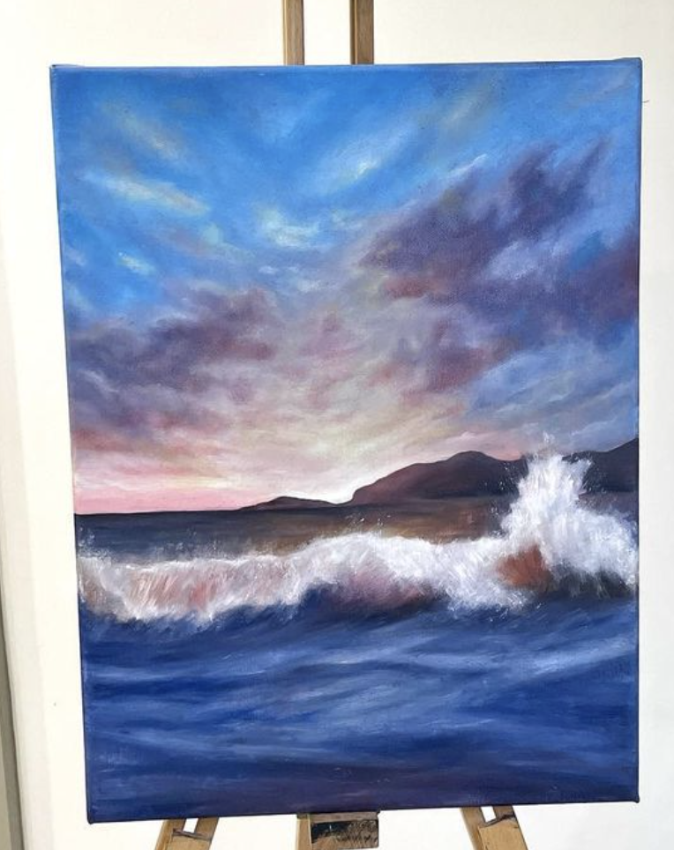

Shop Assistant, Finnerty’s Pharmacy, Tipperary, 2015 – 2015, School Work Placement.
A customer facing role I undertook during the leaving cert summer months to try my hand in the workforce outside of my family business.

- Established clear and effective customer service policies to increase customer satisfaction, patient confidentiality and pharmacy loyalty.
- Provided customers with pamphlets and gave clear verbal advice and instruction on how to properly take, handle and store medication.
- Excellent record keeper and the proficient monitoring of supplies.
- Administrated organisation and supply management policies for all medicine and material.

Experienced Sailor , Swimmer with Water Safety expertise

- With seven years of dedicated sailing experience at Lough Derg Yacht Club in Dromineer, Tipperary, I bring a wealth of expertise in navigating various watercraft, including dinghies, Optimists, Mirrors, Pickos, and a diverse range of Lasers. Alongside my extensive sailing background, I possess exceptional water proficiency and am a skilled swimmer. Holding certifications in CPR and water safety further underscores my commitment to ensuring safety and promoting enjoyment on the water.

Volunteer work in India, Kolkata with The Hope Foundation 2019

- Planned and organized two successful fundraising events, which raised the project over €3000 euro.
- The hope foundation involves helping change the lives of poverty stricken children in Kolkata through education, protection, healthcare and rehabilitation. It was a life changing experience to which I was involved in.
- The work involved working on your own initiative, being flexible in tasks and communications, and having a positive and warm open attitude. I worked with children of all ages and abilities, some with severe physical and mental conditions. I was immersed in the children's play and amusement along with their education and emotional relations.

Mural work for ‘The workshop’ Newport 2023

- Designed and executed large-scale murals for a gym environment, tailoring designs to client specifications.
- Created four distinct walls featuring diverse themes, including the gym’s logo, gender-neutral design elements, and dynamic figures engaging in fitness activities.
- Sketched and painted custom illustrations to enhance the gym’s aesthetic, ensuring a cohesive and engaging atmosphere.

Mural work for ‘Atlas High performance centre’ Limerick 2024

- Designed and painted two large-scale murals tailored to the branding and aesthetic of the high-performance gym.
- Featured the gym’s logo prominently on one wall and the business name integrated with dynamic, modern design elements on another.
- Delivered professional, high-quality mural work that aligned with the client’s vision and branding goals.

Referees available on request.

Artist, 2020 – present day

In my art portfolio, I showcase a diverse range of personal and commissioned works spanning various mediums, including painting, pencil drawings, sculpture and murals. Each piece reflects my unique artistic style and meticulous attention to detail. From intricate pencil portraits, vibrant oil landscapes, abstract sculpture and captivating mural designs, my portfolio demonstrates versatility and skill across different artistic disciplines. You can explore my extensive collection of commissioned artworks on my Instagram portfolio, where each piece tells a story and captures the essence of my creative vision.

Photography
Cooking
Painting / Drawing
Animal Lover
Camogie Player
Music Lover
Style & Fashion
Humanitarianism
Please find a link to my Instagram page to view my art portfolio here https://www.instagram.com/hannahmai_art/
HOBBIES
Content Creation – Adobe Suite, Canva
Content Scheduling - Buffer
Social Media – Facebook, Twitter and Instagram
Video Editing
Customer Experience
Stock Taking
Cash Management
Barista Trained
Interpersonal Skills
Time Management
Outgoing
Team Player
Organised
People Management

SKILLS

